

LightForms: A Business Application Generator
Automatic Generation of Data Centric Applications
Friday, 9 of April 2010 – Ponta Delgada, Portugal
João Paulo Pavão Carreiro
joaopaulocarreiro@gmail.com

1. Introduction

Business applications (BA) are comprised of three main components: data definitions, business logic to operate on these definitions and a user interface. Standard development of these applications requires that a substantial amount of work be done before the actual business logic of the application is developed. There are numerous aspects to consider, things like programming languages, database systems, user interface libraries, configurations, build systems, security issues, etc. Although all of this work is perfectly achievable using general purpose tools and programming languages, it is a time consuming and error prone process. This is especially true when designing and programming graphical user interfaces, although they are not difficult components to program, they do take a substantial amount of time to write and using conventional techniques, it is hard to achieve a quite desirable property in application design theory, which is to separate presentation and business layers. Another development task that usually is time consuming is storage of persistent data. Creating, managing and accessing database systems using traditional approaches is a slow development process. It usually implies setting up communication pathways between client and server applications, and other, very specific details about the used database system, and if so happens that we want or need to change the underlying database system, we need to rewrite part of our implementation, even if the application logic did not change at all. Business application developers should only worry about their application’s business logic and not think about how to perform mundane tasks, like the way the data is retrieved or stored, all of these issues should be hidden away in a lower software layer.

What we propose in this document is a complete integrated solution to address and to abstract all of these issues, making the development of business applications easier, faster and more reliable. Moreover, our abstractions will provide us with a system where applications can be specified independently of operating systems, window systems and platforms. We will be using a set of constructs to abstract all the specifics in a clean and structured specification, where only essential information needs to be written, and leave the rest to be automatically generated by the system.

The main objectives for this project are to:

- increase productivity & integration when developing BAs;
- reduce time to market, increasing competitiveness;
- reduce costs with the development of software;
- increase reliability and availability;
- reuse of software, based on a modular design approach;

The tools necessary to reach these objectives are centered on the concept of a specific-purpose programming language for business applications called XMLight. This programming language allows the specification of all the important aspects of programming a business application, from the data model definitions and user interfaces to the business logic necessary to perform the required tasks, as Figure 1.1 suggests. XMLight tries to combine harmoniously the three primary subjects when developing business applications.

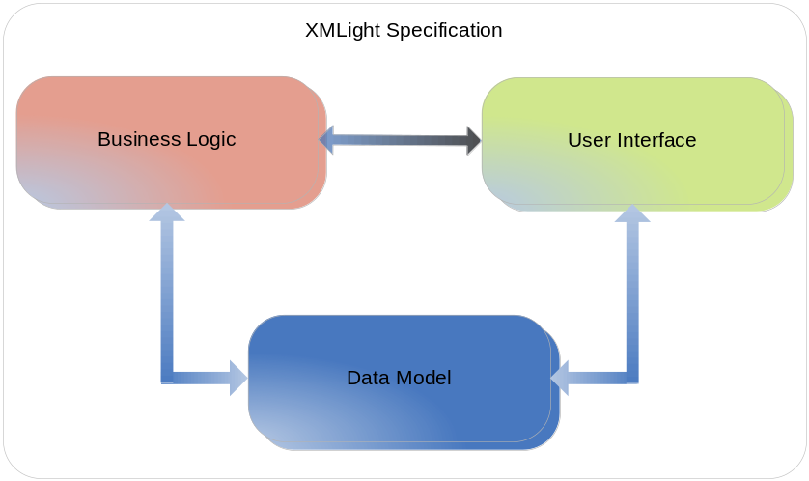

Figure 1.1 – XMLight Specification Elements

XMLight is a XML based language, is main purpose is to make life easy when implementing business applications easier and faster. We will take a detailed look at the XMLight in a latter chapter.

2. System Architecture
3. Development Environment – XMLight

What is an application? It’s basically a computer program aimed at solving a specific problem, our domain. If we take a look at it from a closer look, we will see a set of components

4. Runtime Environment
4. Case Study: Personal Agenda
5. Conclusions
6. Future Work

